EQUATOR RESOLUTION
Institutional Mediation, Conciliation & POSH Support
www.equatorresolution.com · An Infrabyx Group Venture

Workplace & HR Dispute Resolution
Platform Design, Legal Framework & Operating Blueprint
Resolving employment, wage, full-and-final, separation and grievance disputes —
and supporting POSH compliance — fairly, confidentially and enforceably.

Document  Version / Date  Prepared for  Regulatory basis  Classification  Companion assets | Master Blueprint — Workplace & HR Vertical  Version 1.0 · July 2026  Equator Resolution (Infrabyx Group)  POSH Act 2013; Mediation Act 2023; the four Labour Codes (in force 21 Nov 2025); DPDP Act 2023  Strictly Confidential — Internal & Advisory  Forms Pack · Developer Workbook · Diagrams · Calculators · Deck · Toolkit · Prototype

Document Control & Disclaimer
This Master Blueprint is a working draft for legal sign-off, prepared for Equator Resolution (an Infrabyx Group venture; www.equatorresolution.com). It is not legal advice. All statutory references — the POSH Act, 2013, the four Labour Codes, the Mediation Act, 2023 and related rules — must be confirmed by qualified counsel and a Data Protection Officer before the platform goes live or any document is used with a real party.
A note on sexual-harassment (POSH) matters
Equator supports employers' Internal Committees (including by providing trained external members and secure case management) and facilitates the statutory conciliation under s.10 of the POSH Act at the aggrieved woman's request. It does not replace the Internal Committee, does not permit any monetary settlement as the basis of POSH conciliation, and does not handle criminal proceedings. Safety and the complainant's autonomy come first.

Law stated as at July 2026. The four Labour Codes are in force nationwide from 21 November 2025; state rules are being notified progressively — confirm the position in the relevant State.
Table of Contents
This document uses Word heading styles. Open in Microsoft Word and choose “Update Field” on the entry below to generate a clickable, page-numbered contents list.
Right-click and choose “Update Field” to build the Table of Contents.

PART A
Executive Summary & Vision
1. Executive Summary
Workplace disputes — unpaid wages and full-and-final dues, contested terminations, separation and notice-period disputes, benefits, grievances, and sexual harassment — are among the most common, most sensitive and most poorly served disputes in India. Litigation and labour adjudication are slow and adversarial; the sexual-harassment framework, though robust on paper, is unevenly implemented. Equator Resolution offers an institutional, confidential, largely online service that mediates the disputes that are capable of settlement, supports employers' statutory obligations (especially POSH), and routes every matter to the right forum.
This Blueprint sets out the legal landscape, the platform design, the forms, the governance and commercials, global best practice, the technology layer, and the full set of ready-to-use forms.
2. The Opportunity
- Scale. Every establishment has employment, wage, separation and grievance disputes; POSH compliance is mandatory for organisations with 10 or more workers.
- Pain. Labour courts and tribunals are slow; F&F and wage disputes drag; terminations breed litigation; POSH inquiries are often mishandled for want of trained committees.
- Regulatory push. The four Labour Codes are now in force (21 Nov 2025), consolidating 29 laws and formalising grievance-redressal machinery; the POSH Act mandates Internal Committees with an external member; the Mediation Act, 2023 makes mediated settlements enforceable as decrees.
- Employer demand. Employers want faster, cheaper, reputation-safe resolution and reliable POSH compliance; employees want fair, dignified, prompt outcomes and a clean exit.

3. Vision
To be India's trusted institution for resolving workplace disputes — fair to employees, efficient for employers, and impeccable on the sensitive matters — delivered online, secured by escrow where money is involved, and enforceable in law.
4. How Equator Works — Workplace
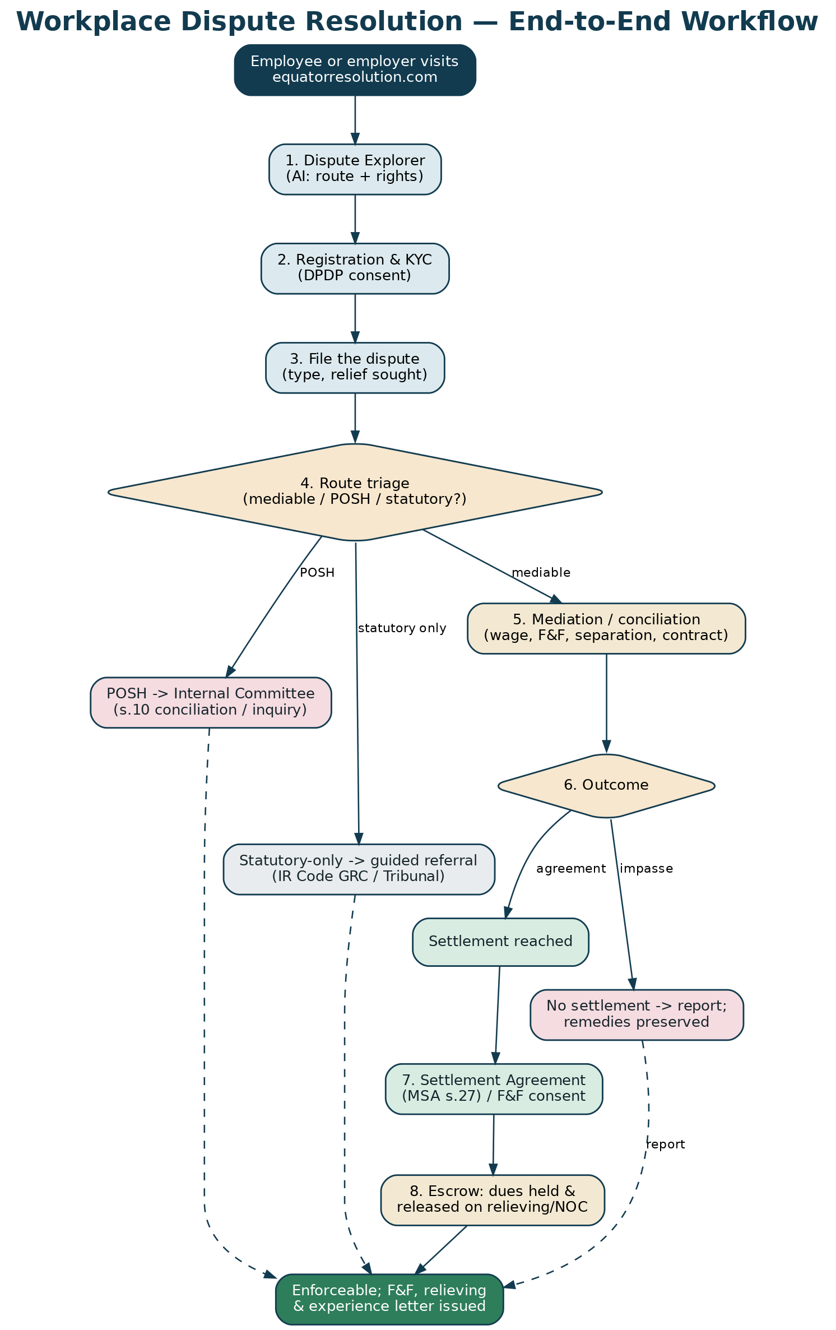
Figure 1 — the workplace dispute lifecycle, from intake to enforceable outcome.
- Explore. The AI Dispute Explorer helps a party understand the route, their rights and remedies, and drafts a first grievance/complaint.
- Register & file. KYC and DPDP consent; either the employee or the employer may initiate.
- Triage. We classify the matter — mediable (wage/F&F/separation/contract/grievance), POSH (to the Internal Committee), or statutory-only (IR Code machinery) — and route accordingly.
- Resolve. A conflict-checked neutral mediates; POSH matters are supported through the Internal Committee and s.10 conciliation where lawful.
- Settle & secure. A settlement/F&F, e-signed and e-stamped, enforceable as a decree; money held in escrow and released against relieving and clearance.
- Close. Relieving and experience letters; confidential record and audit trail.

PART B
The Legal Landscape
5. The Mediation Framework
The Mediation Act, 2023 governs institutional mediation. A mediated settlement agreement (MSA) is final and binding and enforceable as a judgment/decree of court (s.27), may be registered (s.20), and is confidential and without prejudice (s.22). Employment and workplace money/contract disputes are generally amenable to mediation. The Act's First Schedule and general law exclude certain matters; sexual-harassment complaints are dealt with under the special POSH regime, not diverted into ordinary mediation.
6. The POSH Act, 2013
The Sexual Harassment of Women at Workplace (Prevention, Prohibition and Redressal) Act, 2013 ('POSH') requires every employer with 10 or more workers to constitute an Internal Committee (IC) and provides a Local Committee (LC) at the district level for smaller establishments and for complaints against the employer.
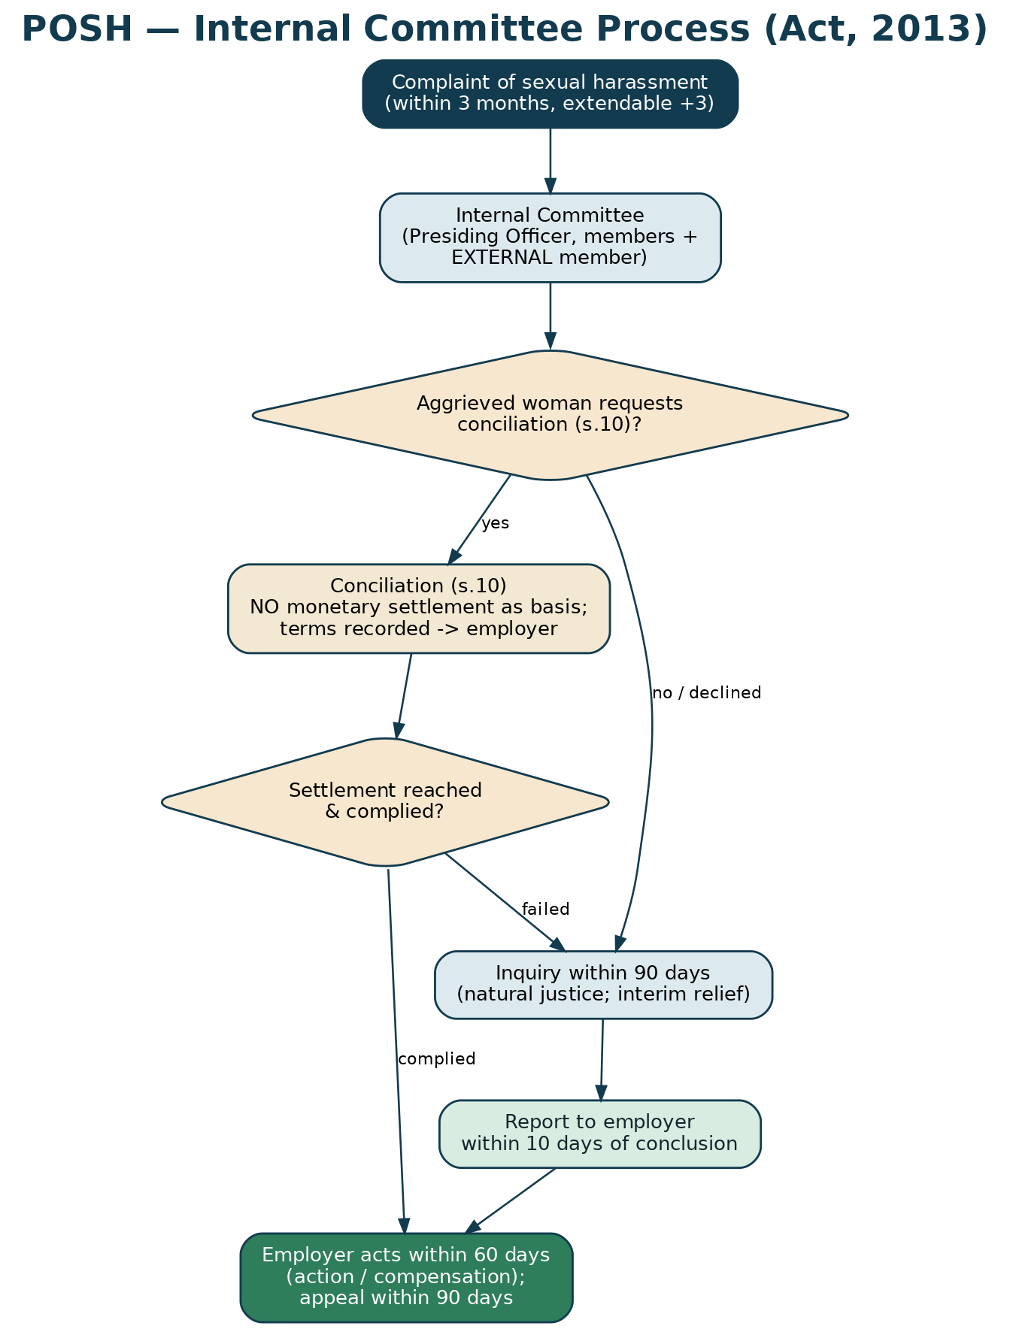
Figure 2 — the POSH Internal Committee process and timelines.
6.1 Key features
- Composition (s.4). A Presiding Officer (a senior woman employee), at least two members, and at least one external member from an NGO/association committed to the cause of women, or a person familiar with sexual-harassment issues. At least half the members must be women.
- Complaint. In writing, ordinarily within 3 months of the incident (or the last incident), extendable by a further 3 months for recorded reasons; assistance is available to file.
- Conciliation (s.10). Before an inquiry, and only at the aggrieved woman's request, the IC may attempt conciliation. It cannot be initiated by the IC on its own or at the respondent's request, and no monetary settlement may be the basis of conciliation. Terms, if agreed, are recorded and sent to the employer for implementation.
- Inquiry. If there is no conciliation (or it fails), the IC inquires following natural justice and completes it within 90 days; interim relief (e.g., transfer, leave, stop-contact) may be granted.
- Report & action. The IC reports to the employer within 10 days of concluding the inquiry; the employer acts within 60 days; either party may appeal within 90 days.
- Confidentiality (s.16). The complaint, the identities and the proceedings are confidential; breach attracts a penalty.
- Employer duties & penalties. Policy, awareness, IC constitution, facilitation, annual report; non-compliance attracts fines and, on repetition, cancellation of licence/registration.

Equator's POSH role
Provide trained external IC members; secure, confidential case management and documentation (F-W07 to F-W10); facilitate s.10 conciliation at the woman's request; IC training. Equator never diverts a POSH complaint away from the IC, never bases conciliation on money, and never handles the criminal aspect.

7. The Labour Codes (in force from 21 November 2025)
India's 29 principal labour statutes have been consolidated into four Labour Codes, now in force nationwide from 21 November 2025 (Central Rules notified in 2026; State rules progressively). They reshape wages, industrial relations, social security and workplace safety.
Code | Consolidates (illustrative) | Workplace-dispute relevance
Code on Wages, 2019 | Payment of Wages, Minimum Wages, Payment of Bonus, Equal Remuneration | Wage/bonus/equal-pay disputes; ‘wages’ = basic + DA + retaining allowance, to be ≥50% of CTC (affects PF/gratuity).
Industrial Relations Code, 2020 | Industrial Disputes, Trade Unions, Standing Orders | Grievance Redressal Committee; conciliation; Industrial Tribunal; termination/retrenchment; standing orders.
Code on Social Security, 2020 | EPF, ESI, Gratuity, Maternity Benefit | Gratuity, PF/ESI, maternity-benefit disputes; final settlement of statutory dues.
OSH & Working Conditions Code, 2020 | Factories, Contract Labour, ISMW, and others | Working-conditions, contract-labour and welfare matters.

Under the Industrial Relations Code, an establishment of the notified size maintains a Grievance Redressal Committee (with adequate representation of women workers) to resolve individual grievances; unresolved matters can become industrial disputes handled by conciliation officers and Industrial Tribunals. Equator complements this machinery and can mediate where lawful.
8. Individual Employment & Contract Disputes
- Wage & F&F dues — unpaid salary, arrears, leave encashment, bonus, incentives, and the full-and-final settlement on exit.
- Termination & separation — contested dismissal, notice period, garden leave, severance/ex-gratia, and mutual separation.
- Contractual — employment-bond recovery, notice-pay in lieu, non-compete and confidentiality (enforceability is limited by s.27 of the Contract Act — reasonable, post-employment restraints are generally void), moonlighting.
- Benefits — gratuity, PF, ESI, maternity benefit, and their correct computation and payment.
- Gig & contract workers — platform/contractor disputes, increasingly within social-security coverage.

9. The Mediable / Non-Mediable Boundary
Equator recognises what it can and cannot resolve by settlement.
Matter | Route | Equator's role
Wage/F&F/separation/contract/benefits | Mediation/conciliation | Primary: settle, escrow, enforceable MSA/F&F.
Individual grievance | GRC → mediation | Mediate where unresolved and both agree.
Sexual harassment (POSH) | Internal Committee | Support IC + s.10 conciliation (no money basis); never replace IC.
Collective/union/statutory industrial dispute | IR Code machinery | Signpost; mediate a settlement where lawful.
Criminal conduct / safety threat | Police / criminal law | Not mediable; signpost; ensure safety.

PART C
The Platform — Design & Workflow
10. Dispute Taxonomy & Dropdowns
The intake captures the dispute precisely so the platform can triage and the AI can assist. Core dropdowns:
Field | Options (dropdown)
Who are you? | Employee / Ex-employee / Employer / Contractor-gig / Union or representative
Dispute type | Wage/salary dues · Full & final (F&F) · Wrongful/unfair termination · Notice period/bond · Gratuity/PF/ESI/benefits · Leave/attendance · Non-compete/confidentiality · Workplace harassment (non-POSH) · Sexual harassment (POSH) · Discrimination · General grievance · Retrenchment/layoff · Contractor/gig
Establishment size | <10 · 10–49 · 50–99 · 100–299 · 300+ (affects POSH/standing-orders/GRC thresholds)
Employment status | Current · Notice period · Separated · Suspended · On leave
Relief sought | Payment of dues · Reinstatement · Relieving & experience letter · Correction of record · Notice-pay waiver · Compensation · Return of documents/assets · Apology/corrective action · Reference/clearance

11. Roles & Access
- Parties — employee/ex-employee, employer/HR, contractor, representative/advocate.
- Neutral — mediator/conciliator (HR/ER/POSH/labour expertise, graded A/B/C).
- Internal Committee — Presiding Officer, members, and Equator's external member (POSH matters only, sealed access).
- Case manager & escrow officer — administration, SLAs, money.
- Confidentiality walls — POSH and disciplinary data are sealed and access-controlled; per-party walls in every matter.

12. Onboarding & Data Protection
Onboarding (F-W01) verifies identity and records DPDP consent. Sensitive categories — POSH, health, disciplinary records — are flagged, masked and access-restricted. Retention follows the published schedule.
13. The Workflow
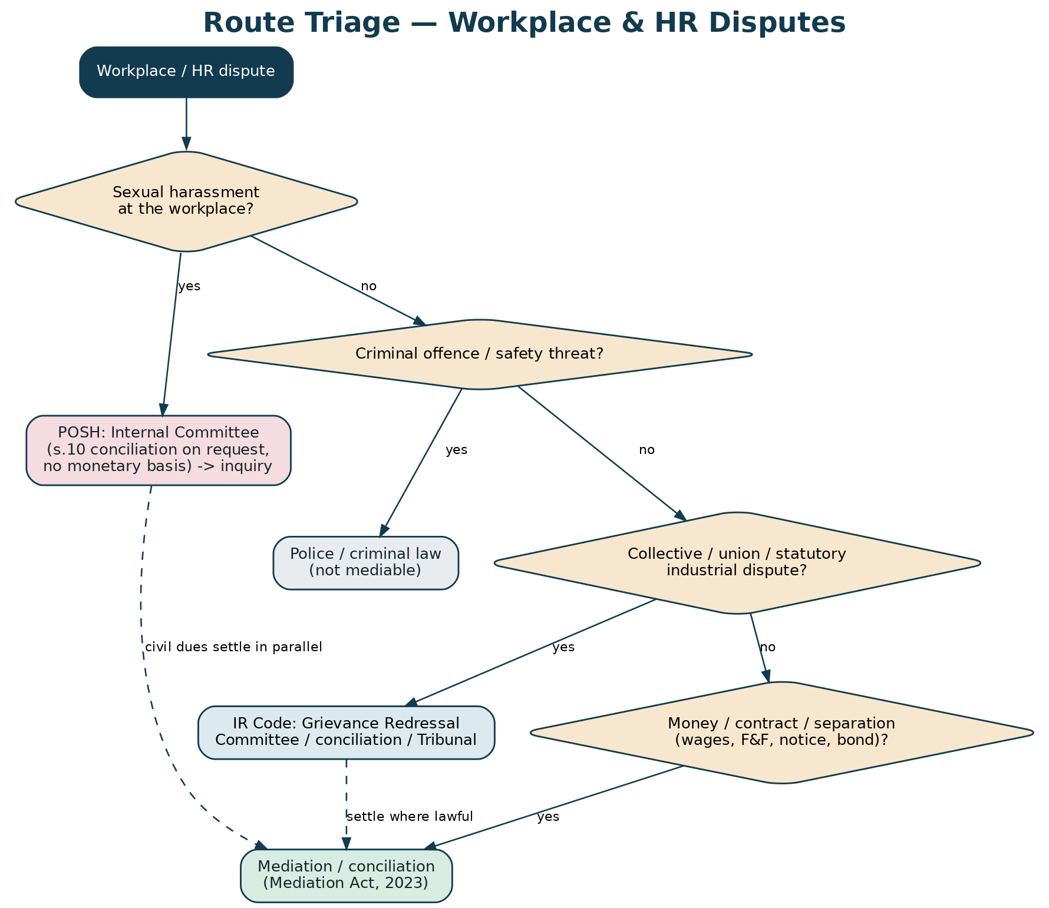
Figure 3 — route triage across POSH, statutory and mediable matters.
- Initiation (either party). Employee or employer files a Request for Resolution (F-W02) or an employee files a Grievance (F-W04); POSH complaints use F-W07.
- Verification & triage. KYC/consent; classify and route (mediable / POSH / statutory).
- Notice & response. The other party is invited (F-W03) and responds (F-W05).
- Neutral / IC. A conflict-checked neutral is appointed (F-W06); POSH matters go to the IC with Equator's external member (F-W10).
- Sessions. Confidential, without-prejudice sessions (online or in person); interests over positions; women neutrals available.
- Settlement. Wage/F&F (F-W11), separation/termination (F-W12), or POSH s.10 conciliation (F-W08); escrow instruction (F-W16).
- Closure. Relieving/experience letters; closure report (F-W17); audit trail.

14. POSH on the Platform
For sexual-harassment matters the platform operates in a sealed POSH mode: only the IC (and Equator's external member and POSH-trained case support) can access the file; s.16 confidentiality is enforced technically; the s.10 conciliation path (F-W08) is available only on the aggrieved woman's request and never on a monetary basis; the inquiry record (F-W09) tracks the 90-day clock and the 10-day/60-day reporting and action timelines. The platform provides interim-relief workflows, awareness content and IC training.
15. Case-Manager Playbook & SLAs
Stage | Target SLA | Owner
Acknowledge intake | Same/next working day | Case manager
Serve notice / invite | 2 working days | Case manager
Appoint neutral / convene IC | 3–5 working days | Case manager
Mediation sessions | Within 2–3 weeks | Neutral
POSH inquiry (statutory) | 90 days | Internal Committee
Settlement & escrow | On agreement | Neutral / escrow officer
Closure & relieving | Within 7 days of settlement | Case manager / employer

16. Settlement, Full-and-Final & Enforcement
Money settlements run through escrow (F-W16), released against relieving and return of assets; the F&F is computed transparently (F-W18) with the calculators; statutory dues (gratuity/PF) are paid, not waived. A mediated settlement/F&F is enforceable as a decree (Mediation Act s.27). Relieving and experience letters and a mutual release complete a clean exit.
17. Permutations (If / Then)
If… | Then…
Employee claims unpaid wages/F&F | Mediation → escrow → F&F + relieving; statutory dues paid.
Contested termination | Mediation → separation settlement (reinstatement or compensation) enforceable as a decree.
Sexual-harassment complaint | Sealed POSH mode → IC; s.10 conciliation only on request; else 90-day inquiry.
Non-compete/bond claim by employer | Mediation, tested against s.27 Contract Act (restraints generally void).
Collective/union dispute | Signpost IR Code machinery; mediate a settlement where lawful.
Criminal/safety element | Signpost police; ensure safety; mediate only the civil/dues aspect if appropriate.

PART D
Governance, Commercials & Operations
18. Forms Register
Twenty forms (F-W01–F-W20) cover the whole journey; the full text is at Part H, and standalone copies are archived.
Ref | Form | Ref | Form
F-W01 | Onboarding/KYC & consent | F-W11 | Wage/F&F settlement
F-W02 | Request for Resolution | F-W12 | Separation/termination settlement
F-W03 | Notice to other party | F-W13 | Agreement to mediate & confidentiality
F-W04 | Employee grievance | F-W14 | Statement of claim (employment)
F-W05 | Response | F-W15 | GRC referral (IR Code)
F-W06 | Neutral selection & disclosure | F-W16 | Escrow instruction
F-W07 | POSH complaint (to IC) | F-W17 | Case closure report
F-W08 | POSH s.10 conciliation | F-W18 | Full & final statement
F-W09 | IC inquiry record | F-W19 | Model employment ADR clause
F-W10 | External IC member appointment | F-W20 | Time extension

19. Fees
Fees are modest and access-friendly: a small registration/administration fee; a neutral fee scaled to the matter; escrow handling on money settlements; concessions for individual employees and small establishments; and employer subscriptions for POSH external-member and IC-support services. A published tariff gives certainty.
20. Risk & Mitigations
Risk | Mitigation
Mishandling a POSH matter | Sealed mode; trained external members; strict s.10/s.16 compliance; never replace the IC.
Coercing a vulnerable employee | Neutrality; voluntariness; independent-advice opportunity; no settlement of statutory dues.
Straying into statutory adjudication | Clear triage; signpost IR Code/police; mediate only where lawful.
Data breach of sensitive HR data | DPDP controls; masking; access walls; breach runbook.
Enforceability doubts | MSA s.27; e-Sign/e-Stamp; counsel sign-off.

21. Roadmap
- Phase 1 (M1–3): Rules, panel, intake, forms, KYC, case management, F&F calculators.
- Phase 2 (M3–5): POSH sealed mode + external-member service + IC training; escrow; e-Sign/e-Stamp; pilot employers.
- Phase 3 (M5–8): GRC/IR-Code interface; HRMS integration; employer subscriptions.
- Phase 4 (M8–12): Scale; publish anonymised outcome data; multi-language.

22. KPIs
- Settlement rate; median time to settle; F&F cycle time.
- POSH: inquiry-within-90-days rate; external-member coverage; IC-training completion.
- Employee-satisfaction and employer-satisfaction scores; repeat-employer rate; escalation/complaint rate.

PART E
Global Best Practice
23. What Leading Systems Do
System | What it does | What Equator adopts
ACAS (UK) | Free conciliation for employment disputes; ‘early conciliation’ before a tribunal claim. | Early, low-friction conciliation; a pre-claim settlement culture.
EEOC / court-annexed mediation (US) | Voluntary mediation of discrimination/employment charges. | Neutral, confidential mediation as a first resort.
Fair Work Commission (Australia) | Conciliation of unfair-dismissal and general-protection claims. | Structured conciliation with clear timelines.
Workplace mediation practice | Interest-based mediation; restorative approaches for conduct. | Interest-based technique; restorative options for non-POSH conduct.

The through-line: conciliate early, confidentially and fairly, keep the parties in control of the outcome, and reserve adjudication for what truly needs it — adapted to Indian law and the special POSH regime.

PART F
Technology — AI, ODR, e-Sign & Integration
24. AI Dispute Explorer (Workplace)
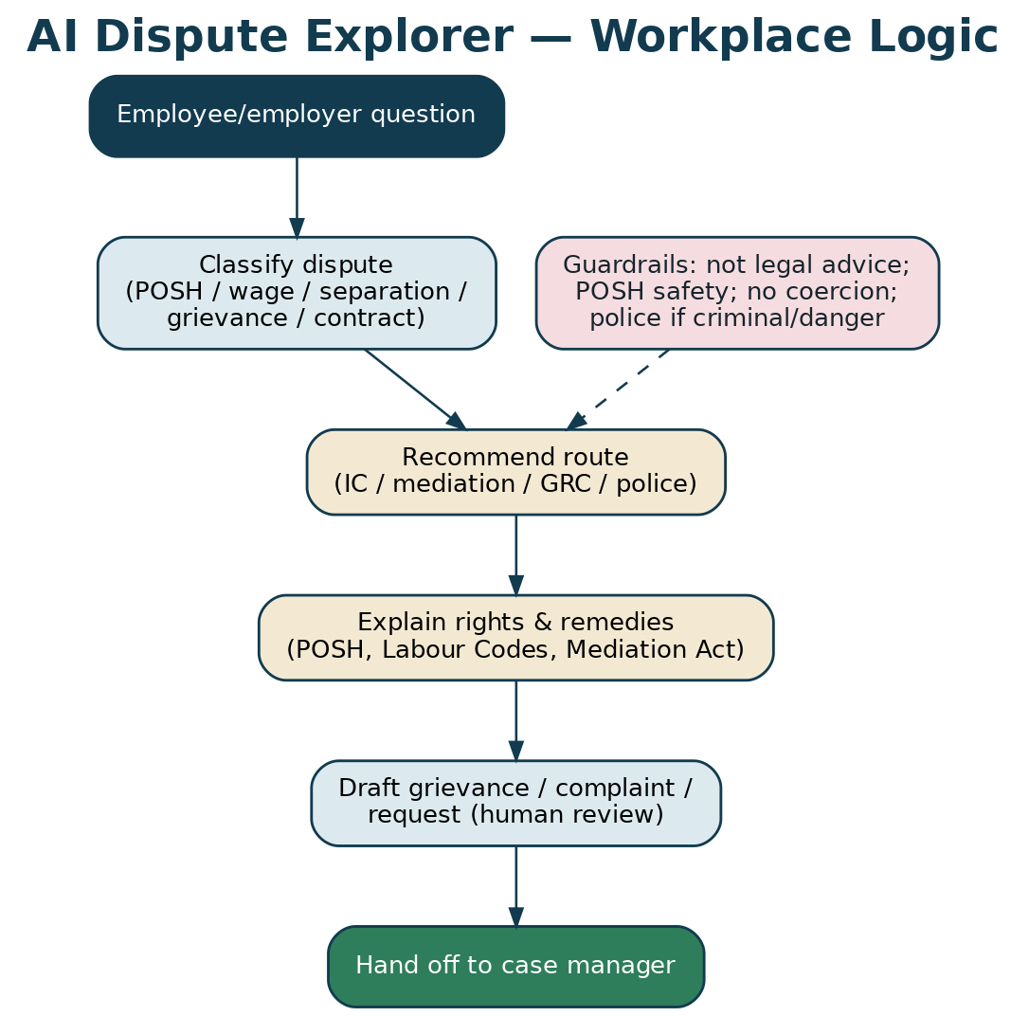
Figure 4 — the AI Dispute Explorer's workplace logic and guardrails.
The AI Dispute Explorer helps employees and employers understand the route (IC / mediation / GRC / police), their rights and remedies (POSH, the Labour Codes, the Mediation Act), and drafts a first grievance, POSH complaint or request for resolution for human review. It never gives legal advice, never decides, and on any safety/criminal signal it surfaces the police and safety options.
25. ODR, e-Sign & e-Stamp
The platform runs online: video sessions with private caucus; Aadhaar e-Sign (IT Act s.3A) for filings and settlements; SHCIL e-stamp on the settlement; and escrow for money. A mediated settlement is enforceable as a decree.
26. Integration
- HRMS/payroll — pull employment data and F&F components (with consent) for faster, accurate settlements.
- IC case management — a sealed module for POSH inquiries, the 90-day clock and the annual report.
- Statutory interfaces — signposting and handoff to the GRC, conciliation officer and Tribunal where required.

27. AI Governance & Guardrails
- No legal advice; always a not-advice disclaimer; human review of every AI draft.
- POSH safety first — never discourage a complaint, never suggest a monetary POSH settlement, always surface support and police-if-danger.
- No coercion; data minimisation; sensitive-data care; logging and red-teaming; disclosure that it is an AI assistant.

PART G
Annexures
28. Annexure A — Authorities (law as at July 2026)
Instrument | Relevance
POSH Act, 2013 + Rules | IC, external member, s.10 conciliation (no money basis), 90-day inquiry, s.16 confidentiality, employer duties.
Mediation Act, 2023 | MSA enforceable as a decree (s.27); registration (s.20); confidentiality (s.22).
Code on Wages, 2019 | Wages/bonus/equal pay; ‘wages’ ≥50% of CTC (in force 21 Nov 2025).
Industrial Relations Code, 2020 | Grievance Redressal Committee; conciliation; Tribunal; standing orders; retrenchment (in force).
Code on Social Security, 2020 | Gratuity, PF, ESI, maternity benefit (in force).
OSH & Working Conditions Code, 2020 | Working conditions, contract labour, welfare (in force).
Indian Contract Act, 1872, s.27 | Restraint of trade — post-employment non-competes generally void.

29. Annexure B — Glossary
IC Internal Committee (POSH) · LC Local Committee · GRC Grievance Redressal Committee (IR Code) · F&F full-and-final settlement · MSA mediated settlement agreement · POSH Prevention of Sexual Harassment · CTC cost to company · DPDP Digital Personal Data Protection Act, 2023.
30. Annexure C — Companion Documents
Developer Handoff Workbook; Workflow Diagrams; Forms Pack (archived); Board Deck; Calculators (F&F, gratuity, notice/severance); Neutral & IC Toolkit; Compliance & Security Workbook; Outreach (leaflet + website); the AI Dispute Explorer prototype.
31. Annexure D — Model Clauses
31.1 Employment ADR / grievance clause
Clause
"Any dispute arising out of or in connection with this employment — including wages, dues, separation, benefits or the interpretation of this contract — shall first be referred to mediation/conciliation administered by Equator Resolution under its Rules. This clause does not apply to a complaint of sexual harassment, which shall be dealt with by the Internal Committee under the POSH Act, 2013; nor does it bar a statutory forum or the police where applicable."

31.2 POSH policy reference
Clause
"The Company maintains a Prevention of Sexual Harassment policy and an Internal Committee under the POSH Act, 2013, including an external member. Complaints are dealt with confidentially by the Internal Committee; nothing in any other agreement diverts a POSH complaint from the Committee."

31.3 Full-and-final / mutual release
Clause
"The net full-and-final amount is paid in full settlement of all salary and benefit claims to the separation date, without waiver of statutory dues (gratuity/PF), against relieving, an experience letter and return of Company assets; released through escrow."

These clauses are drafting starting points; adapt and settle with counsel. POSH complaints are never diverted from the Internal Committee.

PART H
The Forms (Full Text)
This Part reproduces every Equator workplace & HR form in full (F-W01 to F-W20), ready to lift into the platform or use directly. The same set is delivered as individual documents in the archived Forms Pack folder. POSH forms (F-W07 to F-W10) support the Internal Committee's statutory role and do not replace it.

Onboarding, KYC & Data-Protection Consent | Form F-W01
Create your account, verify identity, and record DPDP consent.
A. PARTY DETAILS

Name
Role (Employer / Employee / Ex-employee / Contractor / Union rep)
Designation / Employee ID
Organisation / Establishment
PAN / Aadhaar (masked)
Address
Mobile
Email
Authorised representative / advocate (if any)

B. ROLE

I am the:
☐ Employee / ex-employee | ☐ Employer / establishment
☐ Contractor / gig worker | ☐ Union / representative

C. DATA-PROTECTION NOTICE & CONSENT (DPDP Act, 2023)

Your data is processed only to administer the dispute (case management, mediation, settlement, escrow, closure) and for statutory compliance. Sensitive matters (POSH, health, disciplinary records) are kept strictly confidential and access-controlled.
DECLARATION & UNDERTAKING

☐ I give free, specific, informed and withdrawable consent to processing my data for these purposes.
☐ The information provided is true and correct.

________________________  Party  Name / Signature / Date | ________________________  Verified by (Equator)  Name / Signature / Date

Grievance / Data Officer: grievance@equatorresolution.com. Equator acts as a Data Fiduciary under the DPDP Act, 2023. POSH complaints follow the confidentiality rules of the POSH Act, 2013.

Request for Resolution (Workplace Dispute) | Form F-W02
Commences a workplace/HR dispute. Either the employee or the employer may file.
Case No.
Date

1. THE DISPUTE

Dispute type(s):
☐ Wage / salary dues | ☐ Full & final settlement (F&F)
☐ Wrongful / unfair termination | ☐ Notice period / bond dispute
☐ Gratuity / PF / ESI / benefits | ☐ Leave / attendance
☐ Non-compete / confidentiality | ☐ Workplace harassment (non-POSH)
☐ Sexual harassment (POSH) | ☐ Discrimination
☐ General grievance | ☐ Retrenchment / layoff
☐ Contractor / gig dispute

Amount in dispute, if any (₹)
Date of joining
Date of separation (if any)
Is there an employment/ADR clause? (Y/N)

Brief summary of the dispute (facts, dates)

2. THE PARTIES

Name
Role (Employer / Employee / Ex-employee / Contractor / Union rep)
Designation / Employee ID
Organisation / Establishment
PAN / Aadhaar (masked)
Address
Mobile
Email
Authorised representative / advocate (if any)

Other party (name & contact)

3. RELIEF SOUGHT

Relief:
☐ Payment of dues | ☐ Reinstatement
☐ Relieving & experience letter | ☐ Correction of record
☐ Notice-pay waiver | ☐ Compensation
☐ Return of documents / assets | ☐ Apology / corrective action
☐ Reference / clearance | ☐ Other

DECLARATION & UNDERTAKING

☐ I authorise Equator Resolution to administer this matter and to notify the other party.
☐ I understand a mediated settlement, once signed & registered, is enforceable as a decree (s.27).
☐ The information is true to the best of my knowledge.

________________________  Applicant  Name / Signature / Date | ________________________  Received by (Equator)  Name / Signature / Date

If the matter is a sexual-harassment (POSH) complaint, use Form F-W07. If it is a collective/statutory industrial dispute, Equator will guide you to the correct forum (IR Code Grievance Redressal Committee / conciliation / Tribunal) and may mediate any settlement in parallel. Criminal matters are for the police.

Notice to the Other Party | Form F-W03
Issued by Equator inviting the other party to participate.
Case No.
Date
To
Delivery channel

SUBJECT: INVITATION TO RESOLVE A WORKPLACE DISPUTE

Equator Resolution has received a request to resolve a workplace/HR dispute to which you are a party. The process is voluntary, confidential and time-bound; a mediated settlement is enforceable as a decree.
Brief nature of the dispute
Response due within

Please file your Response (Form F-W05) within 14 days. If we do not hear from you, a non-commencement report will be issued and the applicant may pursue other remedies.

________________________
Case Manager, Equator Resolution
Name / Signature / Date

Employee Grievance Form | Form F-W04
For an employee to record a workplace grievance (pay, conditions, treatment, benefits).
Employee name & ID
Department / manager
Date

NATURE OF GRIEVANCE

This grievance concerns:
☐ Wages / dues | ☐ Working conditions
☐ Treatment / conduct | ☐ Benefits (PF/ESI/gratuity)
☐ Leave | ☐ Discrimination
☐ Other

Describe the grievance (facts, dates)

Raised with manager/HR earlier? (date)
Outcome so far

RELIEF SOUGHT

What outcome do you want?

Grievances are handled confidentially. Under the Industrial Relations Code, 2020, an establishment of the notified size maintains a Grievance Redressal Committee; Equator can mediate where the matter is unresolved.

________________________  Employee  Name / Signature / Date | ________________________  Received by (Equator)  Name / Signature / Date

Response | Form F-W05
The other party's reply.
Case No.
Responding party

1. PARTY DETAILS

Name
Role (Employer / Employee / Ex-employee / Contractor / Union rep)
Designation / Employee ID
Organisation / Establishment
PAN / Aadhaar (masked)
Address
Mobile
Email
Authorised representative / advocate (if any)

2. POSITION

We:
☐ Agree to participate and settle
☐ Dispute the claim (state below)
☐ Object to jurisdiction / propose the correct forum

Response to the claim

3. COUNTER-CLAIM / SET-OFF (if any)

Details

________________________  Responding party  Name / Signature / Date | ________________________  Received by (Equator)  Name / Signature / Date

Neutral Selection & Disclosure | Form F-W06
Appointment of the mediator/conciliator and independence disclosure.
Case No.
Proposed neutral
Grade (A/B/C)
Expertise (HR/ER/POSH/labour)

PARTY PREFERENCES

Preference:
☐ Accept the proposed neutral
☐ Request an alternative
☐ Prefer a woman neutral (esp. POSH-related)

DECLARATION BY THE NEUTRAL

DECLARATION & UNDERTAKING

☐ I am independent and impartial and have no conflict with either party.
☐ I will disclose anything that may give rise to justifiable doubts, and will keep the process confidential.
☐ I will not give legal advice or decide the dispute; I will facilitate a voluntary settlement.

________________________  Neutral  Name / Signature / Date | ________________________  Party A  Name / Signature / Date | ________________________  Party B  Name / Signature / Date

A party may challenge a neutral for justifiable doubts as to independence or impartiality; the Institution decides the challenge.

POSH Complaint (to the Internal Committee) | Form F-W07
A complaint of sexual harassment at the workplace under the POSH Act, 2013. Kept strictly confidential.
Complaint no. (office use)
Date of complaint
Establishment

A. AGGRIEVED PERSON (kept confidential)

Name
Designation / ID
Department
Contact

B. RESPONDENT

Name
Designation / relationship to complainant

C. THE COMPLAINT

Please describe the incident(s) of sexual harassment: what happened, where, when, and any witnesses. Attach any supporting material. A complaint should ordinarily be made within 3 months of the incident (or the last incident); the Internal Committee may extend this by a further 3 months for recorded reasons.
Incident details (date, place, description, witnesses)

D. RELIEF / INTERIM RELIEF SOUGHT

I request:
☐ Inquiry by the Internal Committee
☐ Interim relief (e.g., transfer / leave / stop-contact)
☐ Conciliation under s.10 (my request only; no monetary settlement as a basis)

DECLARATION & UNDERTAKING

☐ The information is true to the best of my knowledge.
☐ I understand the proceedings are confidential and that I may be assisted/represented as provided under the Act.

________________________  Aggrieved person  Name / Signature / Date | ________________________  Received by (Internal Committee / Equator support)  Name / Signature / Date

Confidentiality is protected under s.16 of the POSH Act, 2013. This platform supports the Internal Committee (including a trained EXTERNAL member) and does not replace it. If the conduct is a criminal offence or there is a threat to safety, you may also approach the police. This is not legal advice.

POSH Section 10 Conciliation — Request & Terms | Form F-W08
Records a conciliation under s.10 of the POSH Act — only at the aggrieved woman's request, and never on a monetary basis.
Complaint no.
Date

A. REQUEST (by the aggrieved woman only)

DECLARATION & UNDERTAKING

☐ I request conciliation under s.10 before any inquiry. This is my own request; it has not been suggested to me as a condition.
☐ I understand that no monetary settlement can be made the basis of conciliation, and that I may opt for an inquiry at any time.

B. TERMS OF SETTLEMENT (if reached)

Agreed terms (e.g., corrective action, apology, transfer, assurance of no retaliation)

C. RECORDING & IMPLEMENTATION

If a settlement is reached, the Internal Committee records the terms and forwards them to the employer for implementation, and provides copies to both parties. If the respondent does not comply, the Committee may proceed with an inquiry.

________________________  Aggrieved person  Name / Signature / Date | ________________________  Respondent  Name / Signature / Date | ________________________  Presiding Officer, Internal Committee  Name / Signature / Date

Section 10 conciliation cannot be initiated by the Committee on its own or at the respondent's request, and cannot be based on any monetary settlement. This form supports, and does not replace, the Internal Committee's statutory role.

Internal Committee — Inquiry Record | Form F-W09
A structured record of the POSH inquiry (notice, statements, findings) — for the Internal Committee.
Complaint no.
Inquiry commenced on
Target completion (90 days)

A. NOTICE & PARTICIPATION

DECLARATION & UNDERTAKING

☐ The respondent was given a copy of the complaint and 10 working days to reply.
☐ Both parties were given an opportunity to be heard and to lead evidence (natural justice); no legal practitioner represented either party in the inquiry.

B. STATEMENTS & EVIDENCE

Summary of statements, witnesses and documents

C. FINDINGS

Finding:
☐ Allegation proved
☐ Allegation not proved
☐ Malicious/false complaint (with reasons)

Reasons for the finding

D. RECOMMENDATIONS

Action / compensation recommended to the employer

DECLARATION & UNDERTAKING

☐ The inquiry was completed within 90 days and the report is submitted to the employer within 10 days of conclusion.
☐ Confidentiality under s.16 has been maintained throughout.

________________________  Presiding Officer  Name / Signature / Date | ________________________  Member  Name / Signature / Date | ________________________  External Member  Name / Signature / Date

The employer must act on the recommendations within 60 days. Either party may appeal within 90 days. This template aids compliance; it is not legal advice.

External IC Member — Appointment & Undertaking | Form F-W10
Appointment of Equator's trained external member to an employer's Internal Committee (POSH s.4).
Establishment
External member name
Qualification / experience

ELIGIBILITY (POSH s.4)

DECLARATION & UNDERTAKING

☐ I am from an NGO/association committed to the cause of women, or a person familiar with issues relating to sexual harassment.
☐ I am independent of the employer and the parties, and will disclose any conflict.
☐ I will maintain strict confidentiality (s.16) and apply natural justice.

TERMS

Term / tenure
Sitting fee / honorarium
Coverage (complaints, meetings)

________________________  External Member  Name / Signature / Date | ________________________  Employer  Name / Signature / Date

The POSH Act requires the Internal Committee to include at least one external member. Equator provides trained external members and IC training.

Wage / Full-and-Final Settlement Agreement | Form F-W11
Settles salary dues and full-and-final amounts, secured by escrow.
Case No.
Employee
Employer

A. DUES

Component (salary, arrears, leave encashment, bonus, gratuity) and amount

Gross dues (₹)
Deductions / recoveries (₹)
Net settlement (₹)

B. TERMS

DECLARATION & UNDERTAKING

☐ The net amount is in full and final settlement of all salary/benefit claims to the date of separation.
☐ The employer will issue the relieving and experience letters and settle PF/gratuity as applicable.
☐ The amount will be routed through escrow and released against relieving and return of assets.

C. MUTUAL RELEASE

Scope of release / carve-outs (e.g., statutory dues preserved)

________________________  Employee  Name / Signature / Date | ________________________  Employer  Name / Signature / Date | ________________________  Neutral / Equator  Name / Signature / Date

Statutory entitlements (e.g., gratuity/PF) cannot be contracted out; a settlement records their proper payment, not their waiver.

Separation / Termination Settlement (Consent / MSA) | Form F-W12
A consent settlement of a termination/separation dispute, enforceable as a decree.
Case No.
Parties

A. BACKGROUND

The dispute and how it is resolved

B. AGREED TERMS

e.g., separation date, ex-gratia/compensation, notice-pay treatment, relieving & reference, non-disparagement, confidentiality

C. ENFORCEABILITY

DECLARATION & UNDERTAKING

☐ This is a mediated settlement agreement under the Mediation Act, 2023, enforceable as a decree (s.27).
☐ Each party has had the opportunity to take independent legal advice.

________________________  Employee  Name / Signature / Date | ________________________  Employer  Name / Signature / Date | ________________________  Neutral / Equator  Name / Signature / Date

Agreement to Mediate & Confidentiality | Form F-W13
The parties' agreement to mediate and to keep the process confidential.
Case No.
Parties

DECLARATION & UNDERTAKING

☐ We agree to mediate this dispute in good faith under Equator's Rules.
☐ The process is voluntary, confidential and without prejudice (Mediation Act s.22); nothing said may be used in later proceedings, save the signed settlement and the legal exceptions.
☐ We will attend with authority to settle and treat the neutral as impartial.

________________________  Party A  Name / Signature / Date | ________________________  Party B  Name / Signature / Date | ________________________  Neutral  Name / Signature / Date

Statement of Claim (Employment) | Form F-W14
The claimant's structured statement of the employment claim.
Case No.
Claimant
Respondent

1. PARTIES & EMPLOYMENT

Role, dates, terms

2. FACTS

Chronological facts

3. CLAIM & RELIEF

What is claimed and the relief sought

________________________
Claimant / representative
Name / Signature / Date

Grievance Redressal Committee — Referral (IR Code) | Form F-W15
Refers or records a matter before the establishment's Grievance Redressal Committee under the Industrial Relations Code, 2020.
Establishment
Employee
Date

MATTER

The individual grievance referred

GRC COMPOSITION & PROCESS

The Grievance Redressal Committee (with adequate representation of women workers) considers the individual grievance within the statutory timeline; where unresolved, the worker may raise an industrial dispute. Equator can mediate the matter where lawful and both sides agree.
OUTCOME

Decision / referral

________________________  GRC / HR  Name / Signature / Date | ________________________  Employee  Name / Signature / Date | ________________________  Equator (if mediating)  Name / Signature / Date

Escrow Instruction & Release Schedule | Form F-W16
Instructs the escrow agent to hold and release the settlement/F&F sum on milestones.
Case No.
Escrow bank
Amount (₹)

RELEASE MILESTONES

Milestone (e.g., signed settlement / relieving / return of assets) and amount

DECLARATION & UNDERTAKING

☐ Funds are released only against the stated milestones, with a receipt and audit entry for each release.
☐ The final release triggers the relieving/experience letter and confirmation of PF/gratuity settlement.

________________________  Employee  Name / Signature / Date | ________________________  Employer  Name / Signature / Date | ________________________  Escrow officer (Equator)  Name / Signature / Date

Case Closure Report | Form F-W17
Closes the matter and records the outcome.
Case No.
Date of closure

Outcome:
☐ Settled (MSA/F&F signed)
☐ POSH: conciliation recorded / inquiry concluded
☐ Not settled — report issued
☐ Referred to statutory forum
☐ Withdrawn

Summary of outcome and any pending steps

DECLARATION & UNDERTAKING

☐ Documents e-signed/e-stamped as applicable; escrow released; relieving issued where relevant.
☐ Confidentiality maintained; audit trail complete.

________________________
Case Manager, Equator
Name / Signature / Date

Full & Final Settlement Statement (itemised) | Form F-W18
An itemised computation of the full-and-final amount.
Employee
Employer
Last working day

EARNINGS

Component and amount (salary to date, arrears, leave encashment, bonus, gratuity)

DEDUCTIONS

Component and amount (notice shortfall, advances, asset recovery, statutory)

Gross earnings (₹)
Total deductions (₹)
Net payable (₹)

________________________  Prepared by (HR)  Name / Signature / Date | ________________________  Verified by (Employee)  Name / Signature / Date | ________________________  Neutral / Equator  Name / Signature / Date

Use the F&F / Gratuity / Notice-pay calculators to compute the figures. Statutory dues must be paid, not waived.

Model Employment ADR / Grievance Clause | Form F-W19
For inclusion in employment contracts, HR policies and settlement deeds.
MODEL CLAUSE

"Any dispute arising out of or in connection with this employment — including as to wages, dues, separation, benefits or the interpretation of this contract — shall first be referred to mediation/conciliation administered by Equator Resolution under its Rules. This clause does not apply to a complaint of sexual harassment, which shall be dealt with by the Internal Committee under the POSH Act, 2013; nor does it bar either party from a statutory forum or the police where applicable."

Adapt to the role and settle with counsel. POSH complaints are never diverted from the Internal Committee.

Application for Time Extension | Form F-W20
To extend a mediation timeline by consent.
Case No.
Current due date
Extension sought (days)
Reason

DECLARATION & UNDERTAKING

☐ Both parties consent to the extension.
☐ The extension is sought in good faith to reach a settlement.

________________________  Party A  Name / Signature / Date | ________________________  Party B  Name / Signature / Date | ________________________  Neutral  Name / Signature / Date

POSH inquiry timelines are statutory (90 days) and are managed by the Internal Committee, not extended by this form.

